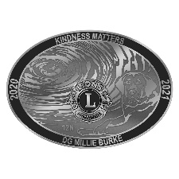
Dear District 12N Presidents, Secretaries and Zone Chairs,

In an effort to help the Lions in District 12N bring Diabetes Awareness, one of our core causes, to the residents of East Tennessee Doug Haseltine our Diabetes Chair is asking that all Clubs in the District begin by taking the attached ADA Diabetes risk assessment test. We do NOT want to know your score, simply that you have taken the time to assess your own score. Please see his attached letter with instructions.

As many of you know diabetes is one of the leading causes of blindness. We can help people by making them aware of their risk and changing some risk factors to hopefully prevent them from becoming diabetic. In many cases diet and exercise can ward off the onset of diabetes and sometimes reverse a person’s numbers.

As an incentive, I will purchase a District 12N Reverse Raffle ticket for any Club which has a fifty percent or higher participation. At the Convention, the top three Clubs will be recognized.

I am also asking all Clubs to make a display board about diabetes that can be used at public awareness or health fair events. Photos of your board are acceptable entries. I would like these for the District 12N Convention April 9 & 10, 2021. Again, I will have awards for the top three which will be judged at the Convention. Thank you in advance for your participation. DG Millie

Millie Burke
gebgem@snet.net
860-912-4171 C
860-326-0676 H

