Prevent Blindness - Prevent Diabetes
More about Diabetes Prevention Program Classes
Clubs throughout the District are having their members do the ADA Diabetes Risk Assessment questionnaire. If a person scores 5 or higher, they are at risk of having Diabetes or Prediabetes. Prediabetes (confirmed by A1c result in the 5.7 to 6.4 range) is REVERSIBLE! Led by trained Lifestyle Change Coaches, the accredited Diabetes Prevention Program (DPP) provides excellent information about diet and exercise. Achieving course goals of 5 to 7% weight loss and physical activity of at least 150 minutes per week often reverses the natural progression from Prediabetes to Diabetes.
If your weight is above that in the table below, are you ready to lose weight? The accountability and support during weekly DPP classes (lasting about 4 months) and extended coaching program (remainder of a year) can make all the difference for lasting change! Total cost for this program is only $25 if led by a UT Extension Agent. Normally it’s over $400.
To be kept informed of Virtual and hybrid course offerings, e-mail Doug Haseltine at haseltin@chartertn.net
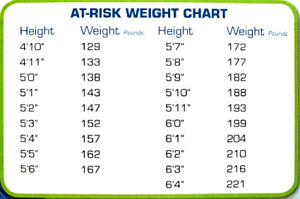
Reference: CDC Prediabetes Screening Test

